NTC-950 Manual

Please read this manual before using your machine.

Contents

- Safety Instructions
- Product Description
- Assembly
- Usage Summary
- Maintenance
- Errors and Trouble Shooting

1. Safety Instructions

- All operators should be properly trained.
- All operators should not wear loose clothing or jewelry. These things may become entangled with the wheel or turntable while using the changer and could cause serious injury.
- All operators should wear protective eye gear.
- The tire changer contains electrical components and should be kept indoors and in a dry environment. Exposure to water can cause damage and is not covered under any warranty.
- Other safety regulations may be in place according to OSHA or your local city and county. These should all be followed in addition to the instructions in this manual.

2. Product Description

Please see www.nationalautotools.com for the specifications on your tire changer.

3. Assembly

Un-package and remove all plastic wrapping from tire changer.

You tire changer should include all of the following parts:

Assist arm parts packaged in smaller box on top of main tire changer:
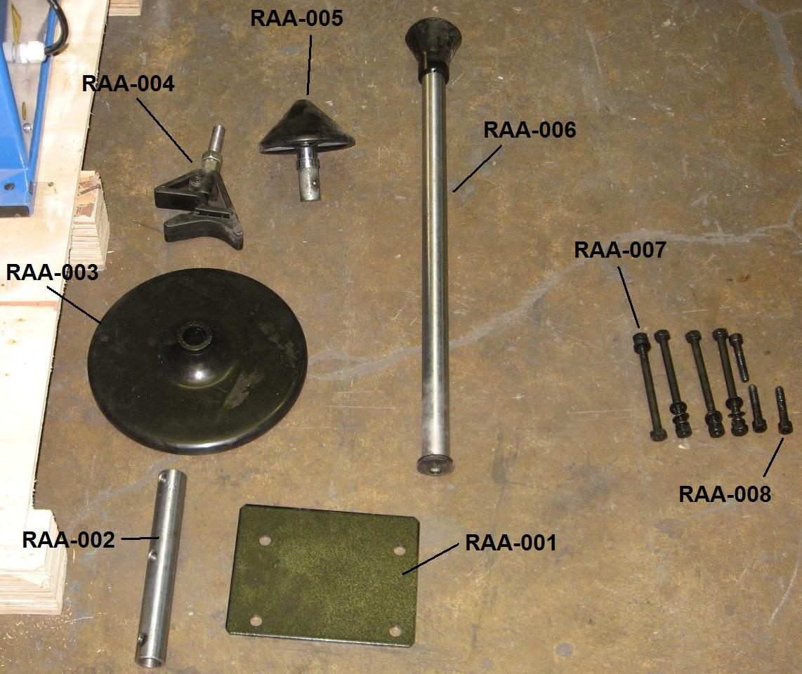

Part number | Description
RAA-001 | Assist arm mounting plate
RAA-002 | Assist arm mounting rod
RAA-003 | Round plastic plate
RAA-004 | Assist arm sidewall push
RAA-005 | Assist arm cone
RAA-006 | Sidewall rolling guide
RAA-007 | Base mounting bolts for use with part RAA-001 and RAA-11
RAA-008 | Assist arm mounting rod bolts for use with part RAA-002

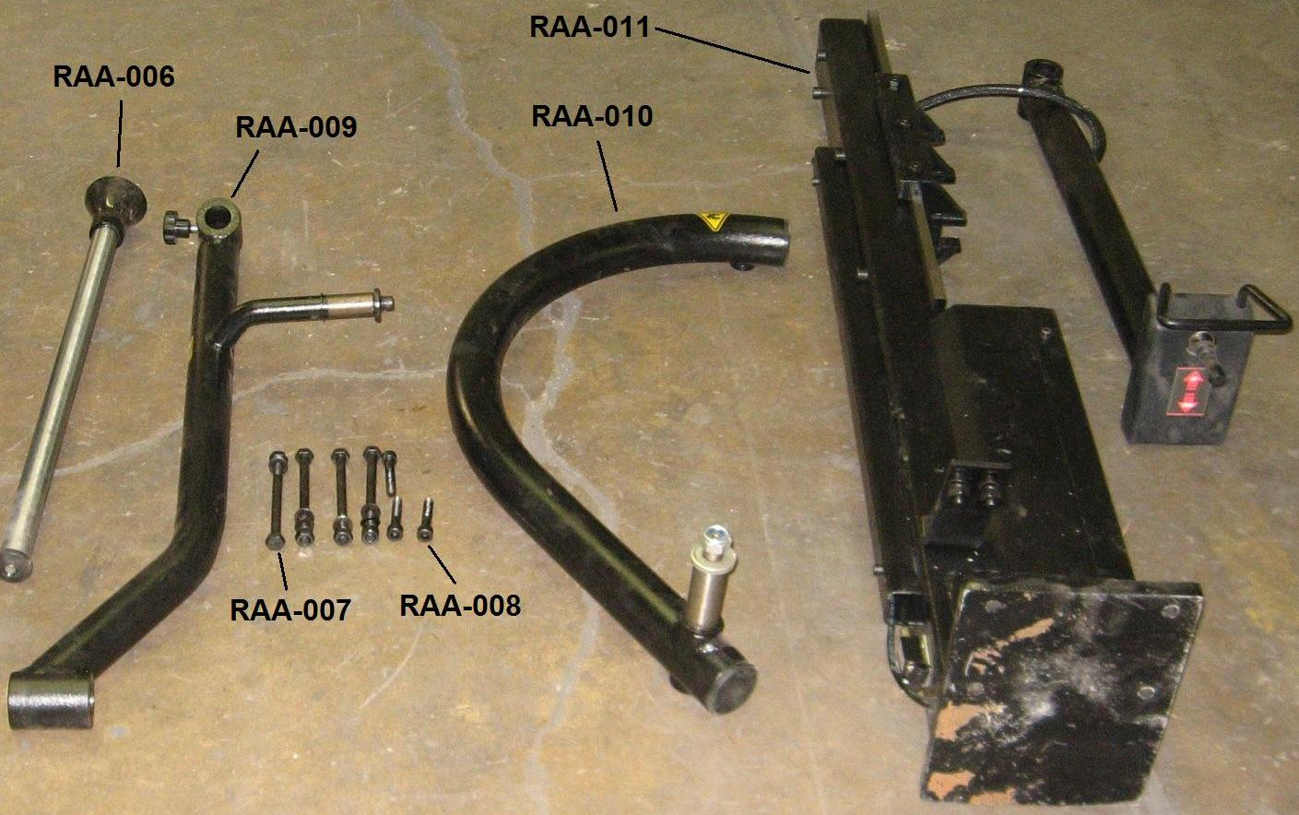

Part number | Description
RAA-009 | Bottom assist arm
RAA-010 | Middle swing arm mounts to top swing arm
RAA-011 | Main assist arm column with pre-connected top swing arm and up down controls

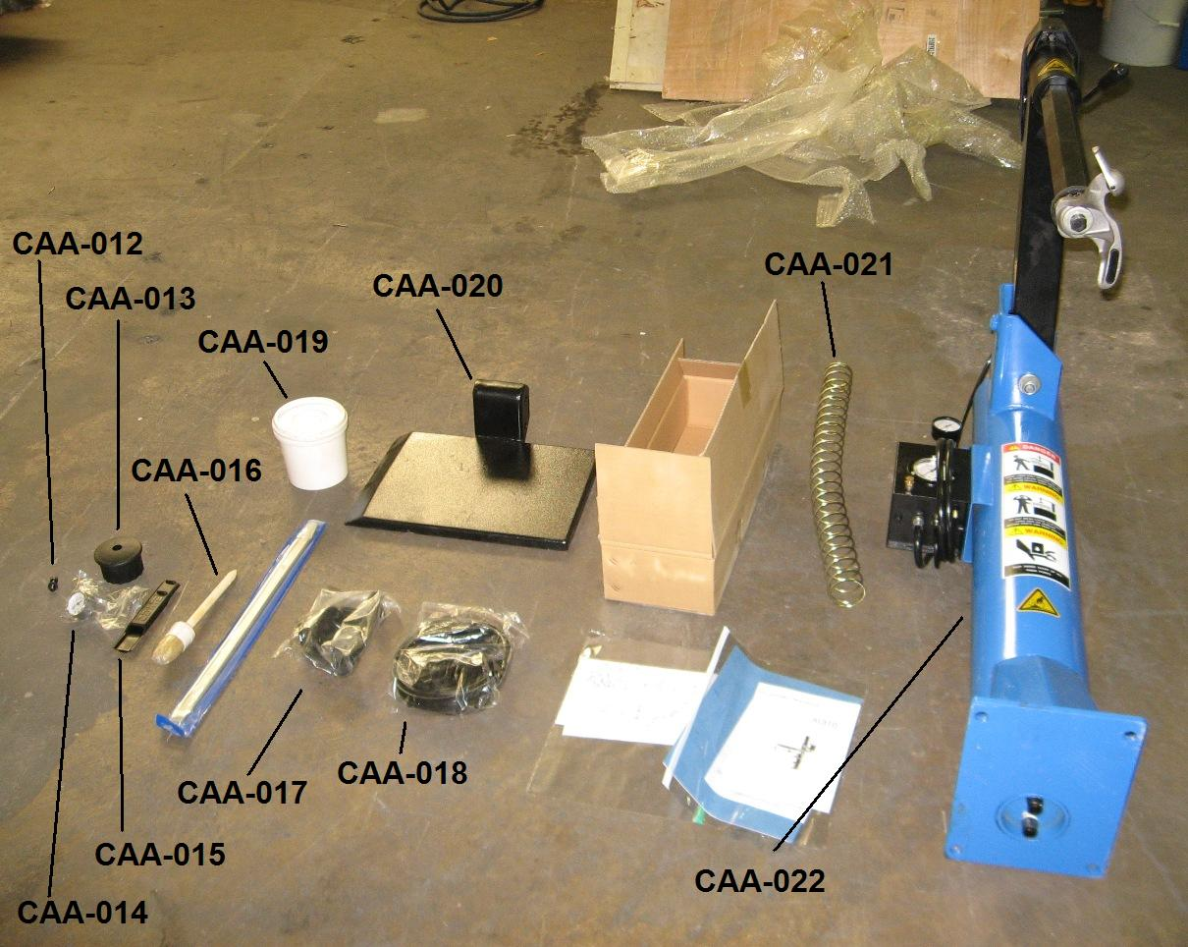

Part number | Description
CAA-012 | Hex cap bolt to be used with part CAA-013 and vertical hexagon mount bar
CAA-013 | Plastic spring retainer cap to be used with CAA-012 and vertical hexagon mount bar
CAA-014 | Air gauge to mount to water separator on back of tire changer
CAA-015 | Crow bar plastic protector
CAA-016 | Soap brush
CAA-017 | Plastic demount head
CAA-018 | Seal kits, plastic inserts for demount head, plastic rim clamp covers
CAA-019 | Soap bucket
CAA-020 | Wheel lift surface
CAA-021 | Spring to be used on vertical hexagon mount bar
CAA-022 | Center assist arm with preinstall vertical hexagon mount bar, metal demount head, tire inflation hose and gauge mounted on black box, air tank gauge

In addition to these parts, the main body of the machine is included. With some preinstalled parts and internal air lines preinstalled.

Steps of assembly:

- Remove the 4 bolts shown here: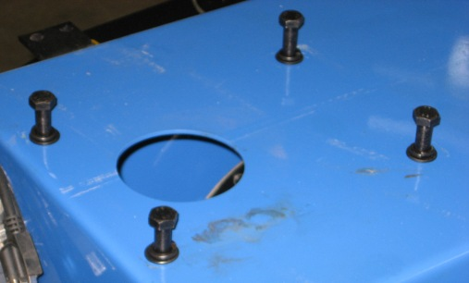
- With the help of 2 people, lift and place the large vertical main column on top of the changer, align with the bolt holes, place and tighten the four bolts. 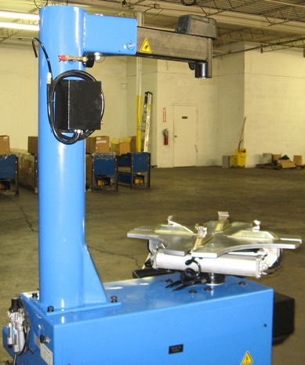
- Place hexagon mounting bar through hole in horizontal swivel bar. The place the large spring over the hexagon bar. Next with the help of another person, push spring down while placing plastic cap on top of hexagon bar and use the hex bolt to keep in place. See picture: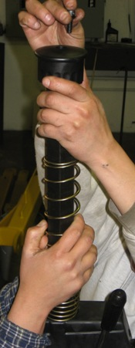
- The result will look like this: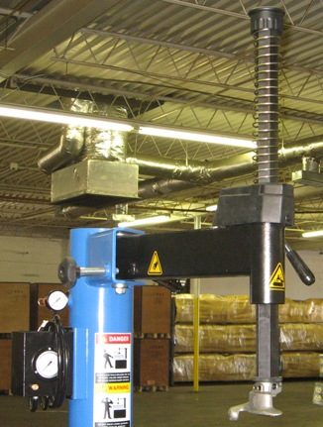
- Hook small air hose from inflating black box to the 90 degree fitting on the back of the tire machine. See picture: 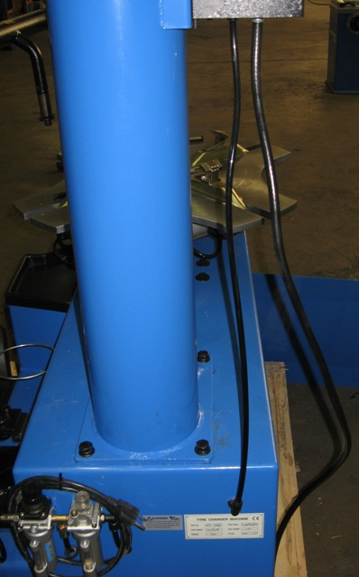
- Open side panel of the tire changer. Install the two size 10 hoses to the bottom of the large vertical main column. These 2 air lines are identical and can be connected to either of the fittings. Connect the hoses to the two fittings shown here: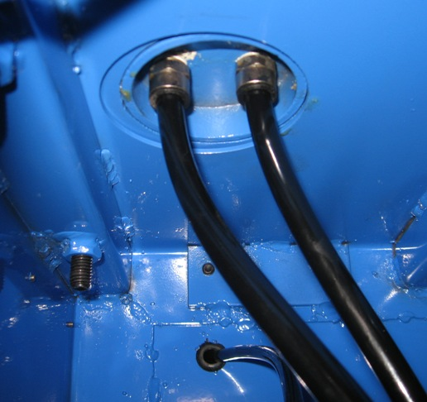
- Install air gauge to water separator on back of machine See picture: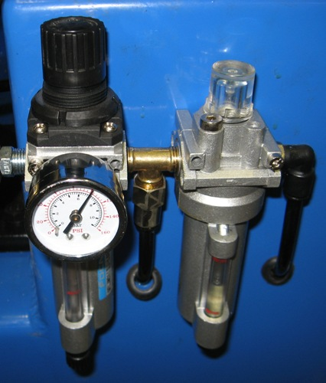

- Connect part CAA-020 wheel lift surface to pre-installed wheel lift mechanism using provided rods and snap rings. 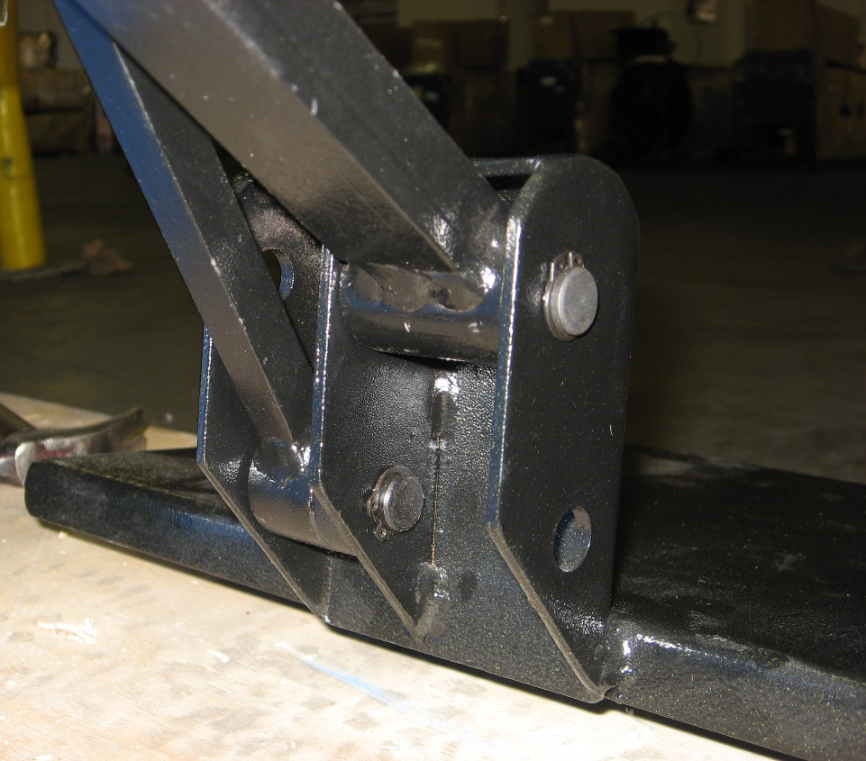

- Assist arm assembly begins by mounting RAA-011 (main assist arm column) to main side of tire changer body using RAA-001 (mounting plate) RAA-007 (mounting bolts). 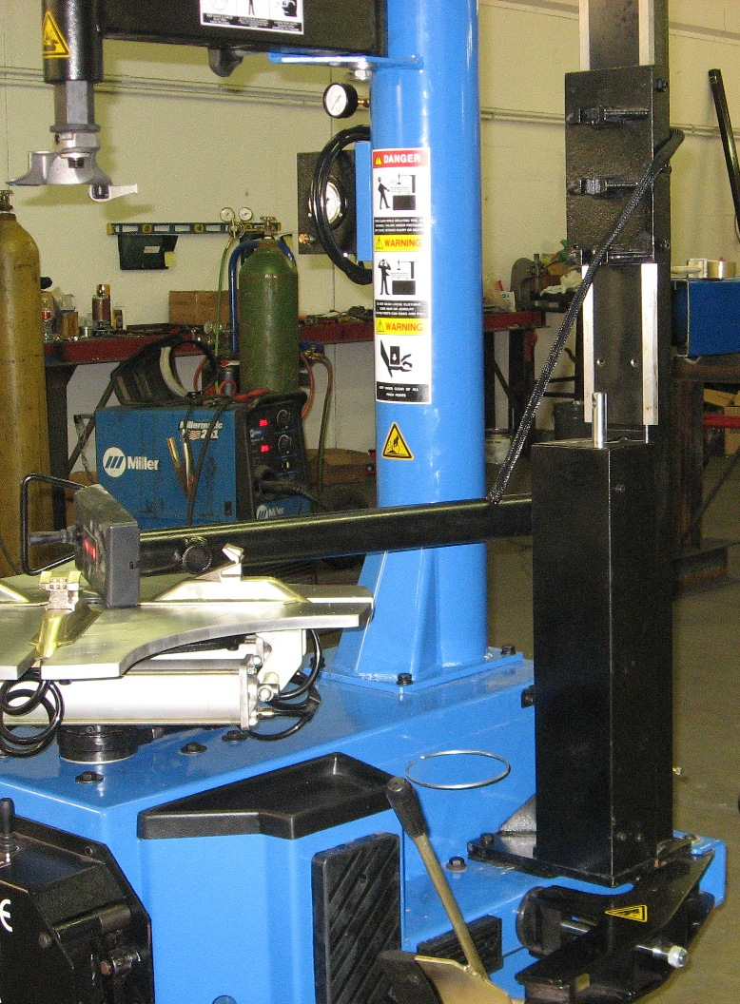

- Place RAA-001 mounting plate on main machine body and align with the holes. Use some tape to hold RAA-001 plate in place. Position RAA-011 main assist arm in position as shown in above picture. Use RAA-007 mounting bolts to bolt RAA-011 and RAA-001 to main machine body. RAA-001 mounting plate must be placed under RAA-011. This allows the bead breaker arm to move freely under without rubbing on RAA-011. 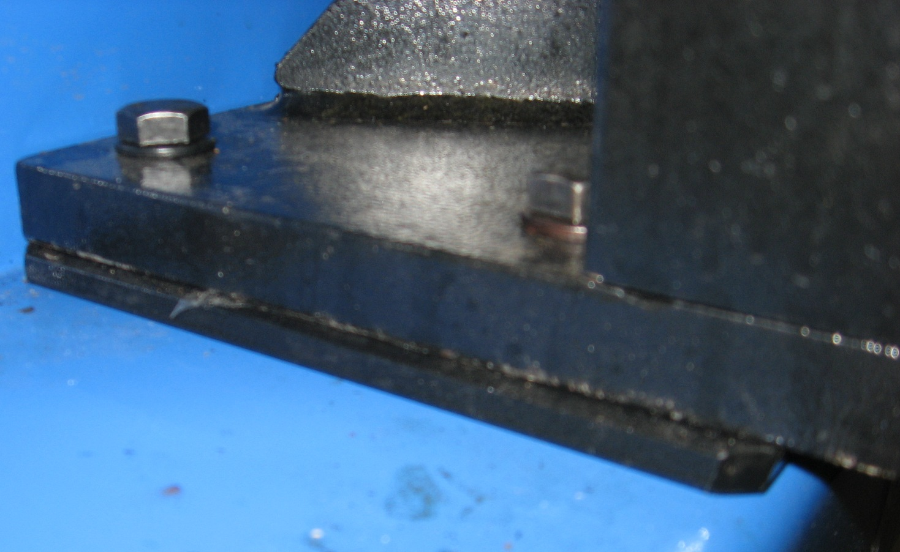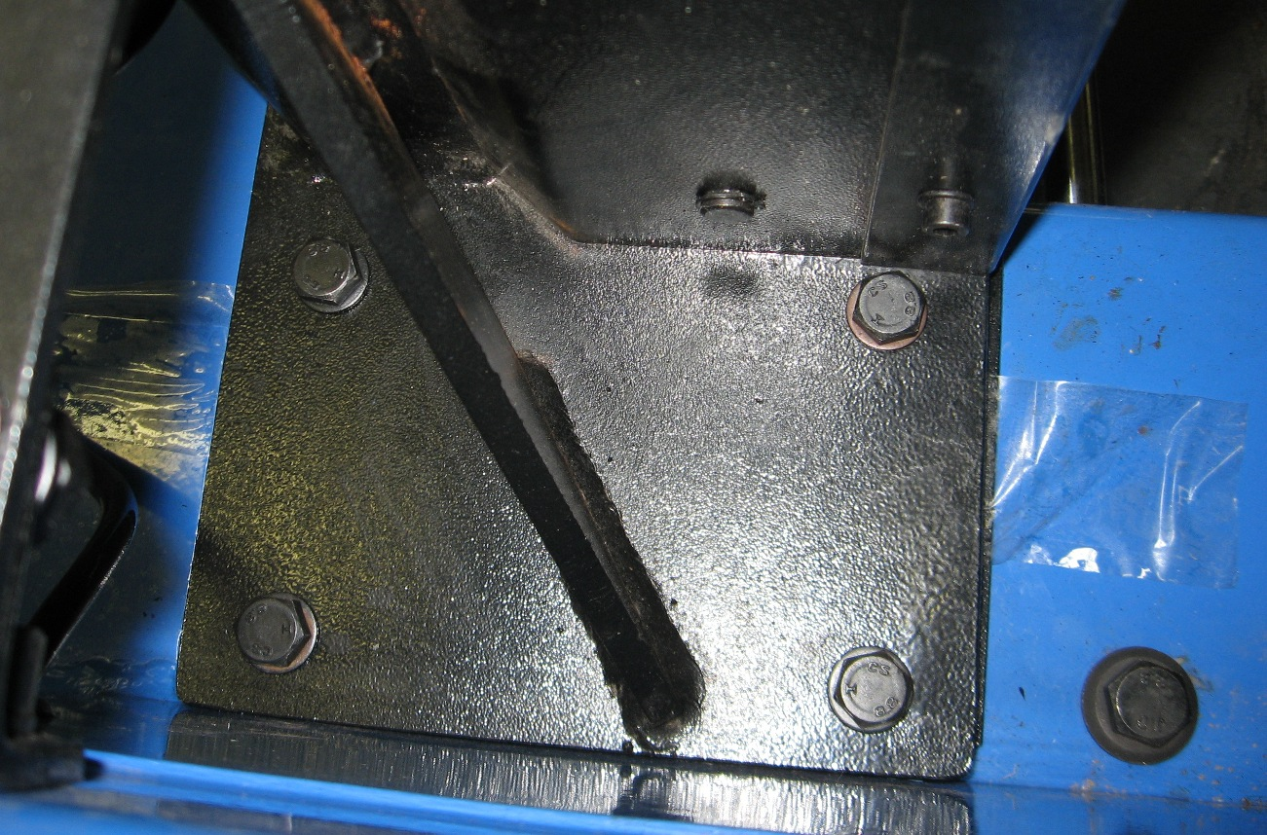

- To complete assist arm assembly, you must first complete air hookup. Connect air hose coming out of main machine body to pre-installed air valve on back of assist arm. 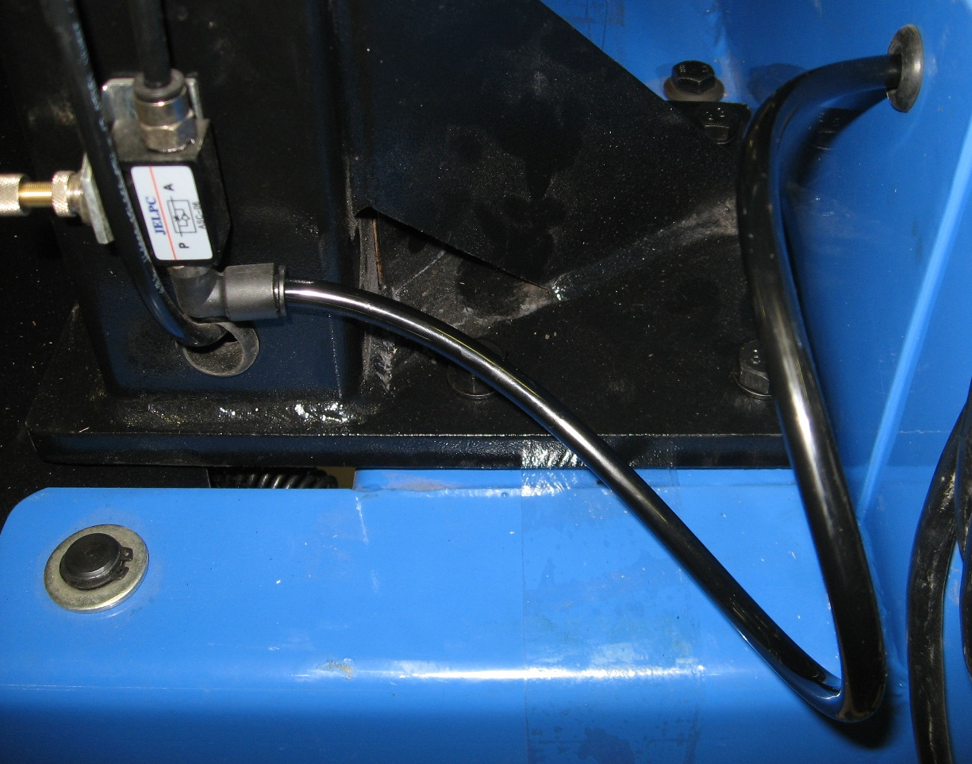

- Connect air to the air gauge on back of machine. Use your own regulator on your compressor to keep air at 100-120 PSI. 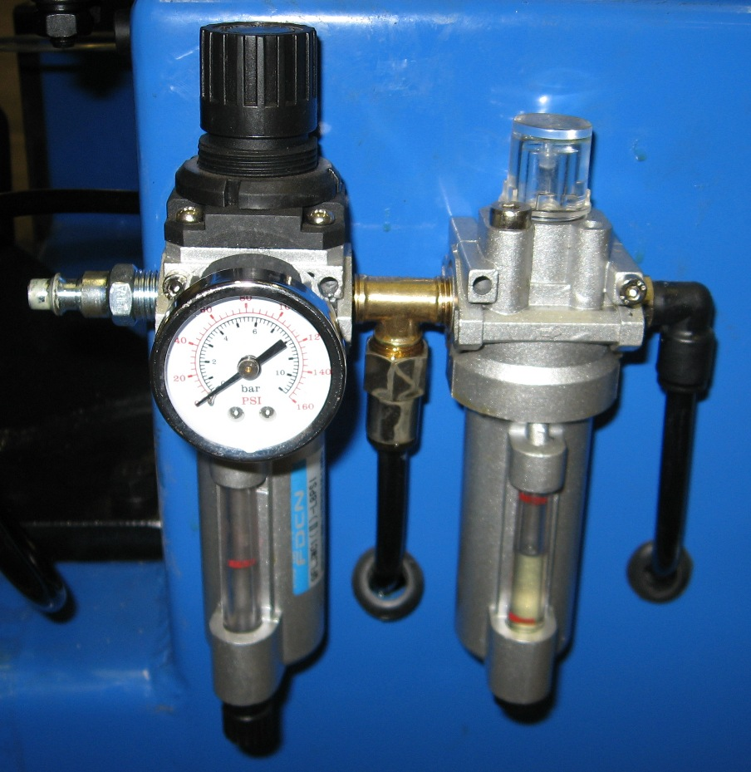

- Now you can continue with assembly of the assist arm. First place top assist arm(arm with up/down controls that is pre-installed to main assist arm) and RAA-009 bottom assist arm in place as shown below. Then place RAA-002 assist arm mounting rod through both assist arms as show below. 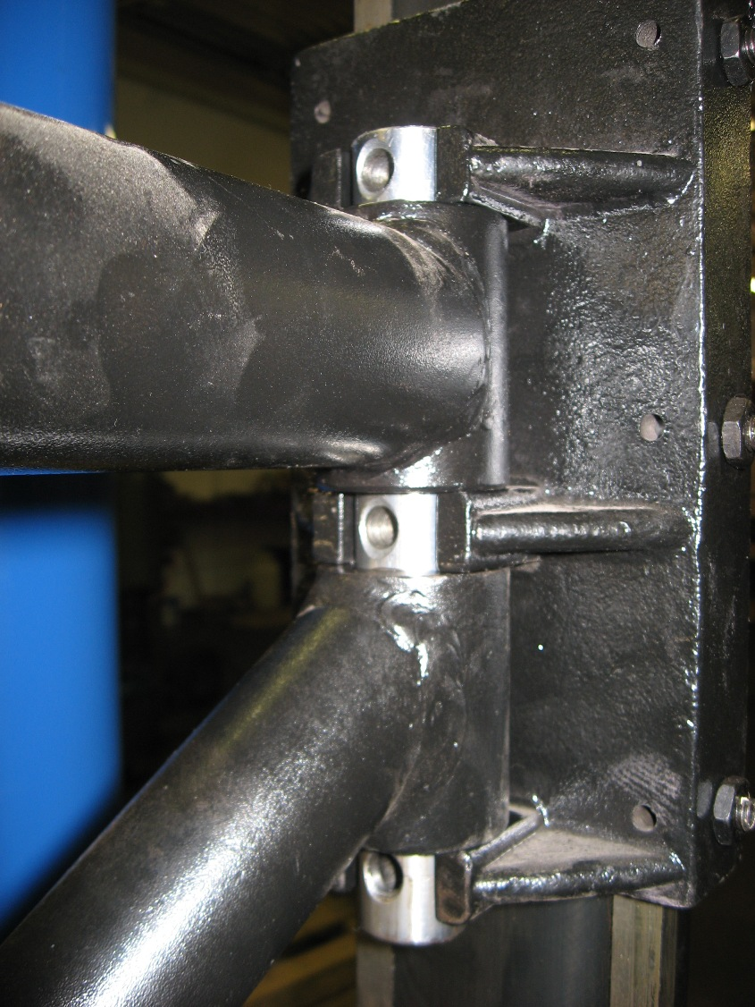

- Then use 2 of RAA-008 mounting bolts in top 2 holes of RAA-002. 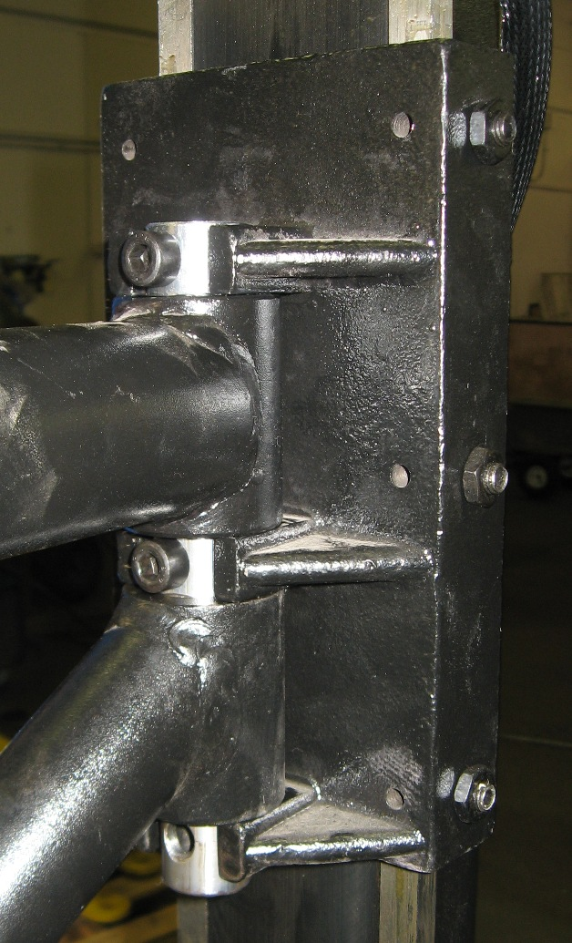

- Now use up/down switch to raise preinstalled rod up and inside RAA-002 as shown below. Then use the other RAA-008 mounting bolt to finish connection. 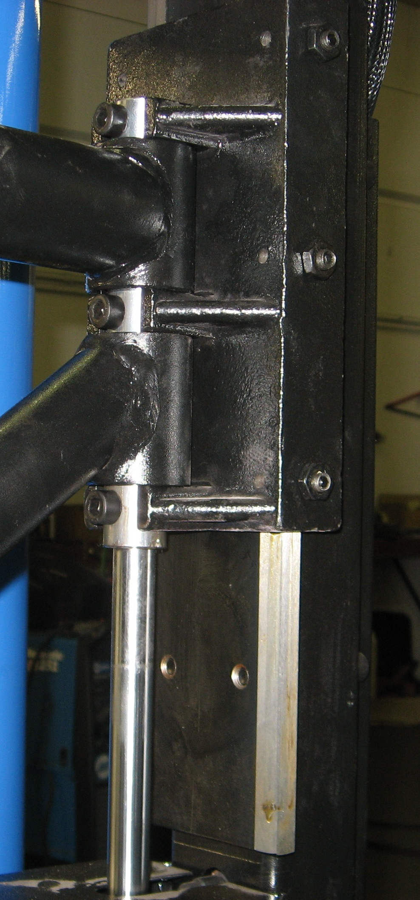

- Now install remaining assist arm parts as shown in below pictures. 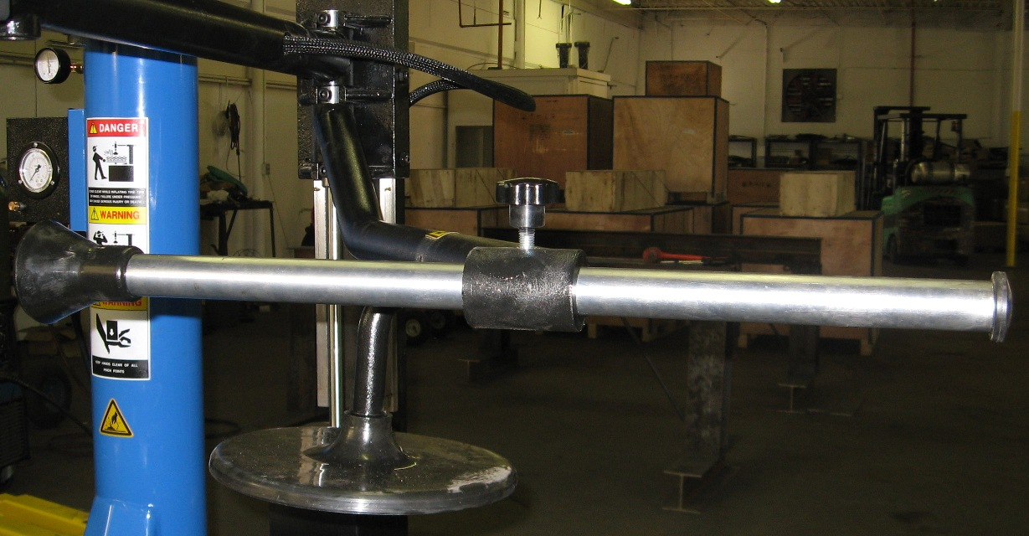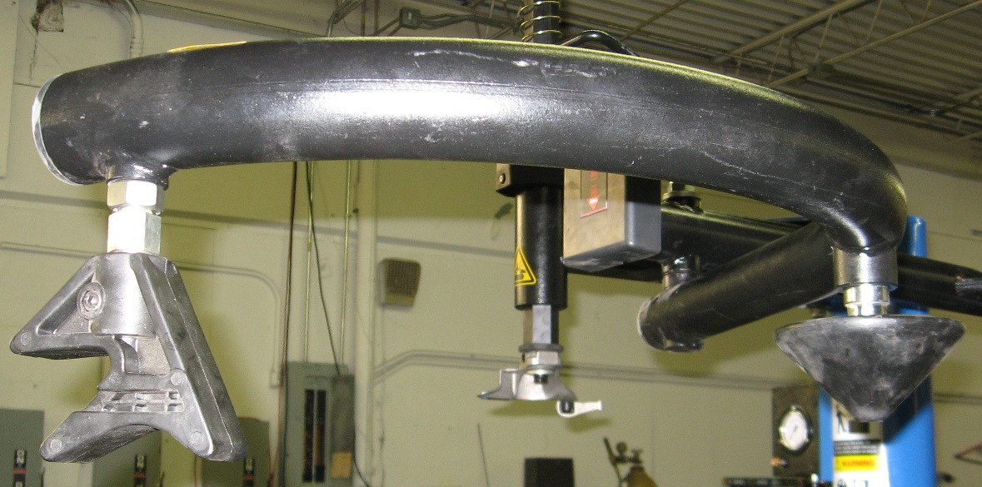

Installation is now complete. Be sure to check compressor oil level in oiler on back of machine before use. Always turn off compressor before connecting to the machine. Once connected to machine, then turn on compressor.

4. Usage Summary

The following is a summary of the different features and steps to using the tire changer. This is not a complete step by step on how to be an expert tire changer. If you have never used a tire changer, we recommend having someone teach you the ins and outs of the process. We also recommend that you practice with an old rim and tire that you do not mind scratching.

You must have an air compressor hooked to the tire changer for all the features to work. Check the compressor oil level on back of machine each day before beginning to use. Remove all wheel weights from the rim before using tire changer.

- First step to changing a tire is deflation. Deflate the tire via the valve. Always deflate the tire before beginning the demount process.
- Remove inflation valve stem from tire.
- Place wheel on side of tire changer against rubber pad. Hold wheel in place while pressing the bead breaker pedal to separate the tire from the rim.
- Release foot pedal, rotate tire, and repeat step 3.
- Repeat step 3 and 4 to separate both side of the tire from the rim.
- Use foot pedal to adjust the rim clamps for clamping outside of rim or inside of rim.
- When clamps are in the desired position, place rim and tire on turntable. Hold the tire in place and press the rim clamp foot pedal. Rim clamps will engage the rim and hold in place.
- Adjust hexagon demount bar so that demount head curve is perpendicular to curve of rim.
- Unlock hexagon demount bar and lower. Position demount head so that there is about ¼” space between rim and demount head. Lock hexagon demount bar.
- Use provided crow bar to raise lip of tire above demount head. Let lip of tire come to rest on tire side of demount head. You may also use part RAA-003 on assist arm to help lift the tire.
- Push pedal to rotate turn table. Rotate turn table until lip of tire is fully above and removed from edge of rim.
- Repeat steps 10 and 11 for bottom/other lip of tire.
- Once tire is fully removed from rim, press rim clamp foot pedal to release rim.
- Unlock hexagon demount bar and raise out of way.
- Remove tire and rim from tire changer.

Repeat steps 6-12 in reverse to mount a new tire on a rim. While mounting new tire on rim, you may use RAA-006 and RAA-004 to help push sidewall of tire down during rotation. Once tire is on rim, hook tire inflation hose to valve and use bead blast/inflation pedal to set bead and inflate the tire. Once inflated, replace valve stem.

5. Maintenance

- Frequently check the compressor oil level of the oiler in the back of the machine. If low, please refill with compressor oil. Do not use any other type of oil. This keeps the air lines lubed and clean and greatly extends the life of the machine.
- Keep any air holes free of dirt.
- Grease the spot where the rim clamp jaws move along the turntable. This will let machine work easier and extend its life.
- Make sure you do not exceed 145 PSI. Remember that the tire changer does not have a pressure regulator. The gauge on the back of the machine is simply that, a gauge. You must put a pressure regulator on your compressor.

6. Errors and Troubleshooting

Error | Solution
Bead Breaker does not move or does not have enough pressure. | Check hose connections and fittings. Check seals inside bead breaker cylinder. If seals are bad, replace seals. Replacement seals were provided with tire changer. Check inside cylinder to be sure there are no gouges in the metal.
Turntable will not turn | Check all wire connections. Check foot pedal and electrical switch. If motor is defective, return motor for inspection and repair or replacement.
Demount hexagon arm will not stay in locked position | Replace locking plate.
One of the air functions do not work | Check foot pedal valve, air lines and fittings for leaks. If air is reaching the foot pedal from the air tank, but not being sent on to final destination, then replace foot pedal air valve.

Copyright © 2010 National Auto Tools, Inc. www.nationalautotools.com

May not be copied or distributed without the permission of National Auto Tools, Inc

